

In the name of God,

the merciful, the compassionate

HomeWork 6  
(State Feedback and PID)

By

Reza Nopour  
402126924

Advanced Automatic Control  
Mechanical Engineering Department  
Amirkabir University of Technology  
24 Dec. 23

# Problem 1 Description

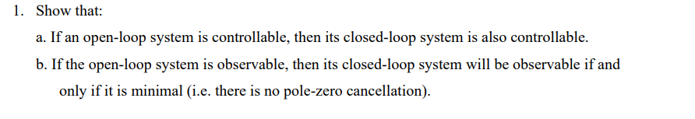

# Solution

To demonstrate that if an open-loop system is controllable, then its closed-loop system is also controllable, we can use the concept of controllability matrices.

The controllability matrix, denoted as (), is defined as:

Now, let's consider the closed-loop system obtained by adding a feedback controller to the open-loop system. The closed-loop system can be represented as:

where () represents the feedback gain matrix. To show that the closed-loop system is also controllable, we need to examine the controllability matrix () for the closed-loop system, defined as:

in which the determinant of matrix is one and shows the controllability matrix of two systems (open and closed) are the same!

b) *\*\*If part (open-loop observable => closed-loop minimal and observable):\*\**

If the open-loop system is observable, then the observability matrix has full rank. Now, let's consider the closed-loop system. If it is minimal (no pole-zero cancellation), then () is full rank. Since () is the same as () in this case, the observability matrix () is formed by stacking the matrices ). Since () is full rank, the observability matrix () also has full rank, and thus the closed-loop system is observable.

*\*\*Only if part (closed-loop minimal and observable => open-loop observable):\*\**

Conversely, if the closed-loop system is minimal and observable, then the observability matrix () has full rank. Now, we can express () in terms of the open-loop matrices:

Now, the observability matrix () is formed by stacking the matrices (), ). Since () has full rank, it implies that the matrices ) are linearly independent.

Consider (). If () is linearly independent, then () (which is a submatrix of ()) must also be linearly independent. Therefore, the observability matrix () has full rank, and the open-loop system is observable.

In conclusion, if the open-loop system is observable, then the closed-loop system is observable *if and only if it is minimal*.

# Problem 2 Description

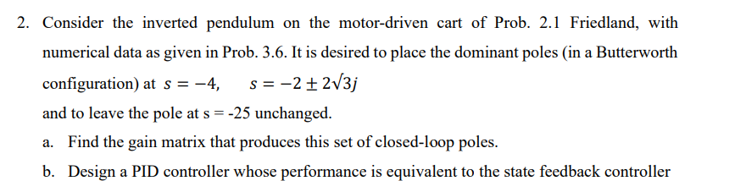

# Solution

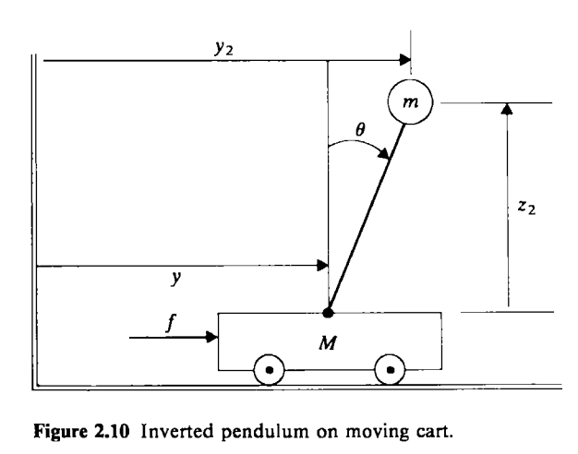

Considering the position of as instead of according to the illustration.

So, the Lagrangian form of this system can be written as,

The system equation of motion can be derived as,

Above equations are nonlinear, considering small rotation, the equation can be rewritten as,

Substituting in yields,

it can be derived as,

Obtained can be inserted into

Final equation can be obtained as,

According to the question,

thus,

State Space representation of this system is,

where,

According to the Ackerman Formula:

1. Designing a PID controller.

For a closed-loop system,

For a closed-loop system,

Evaluating , or the transfer function of the original system as,

***PID for default system:***

Using Routh stability criterion for PID controller, in order to place the poles of the system in the LHP.

|  |  |  |
| --- | --- | --- |
| Routh Criterion | | |
|  | 1 |  |
|  |  |  |
|  |  |  |
|  |  |  |

Therefore,

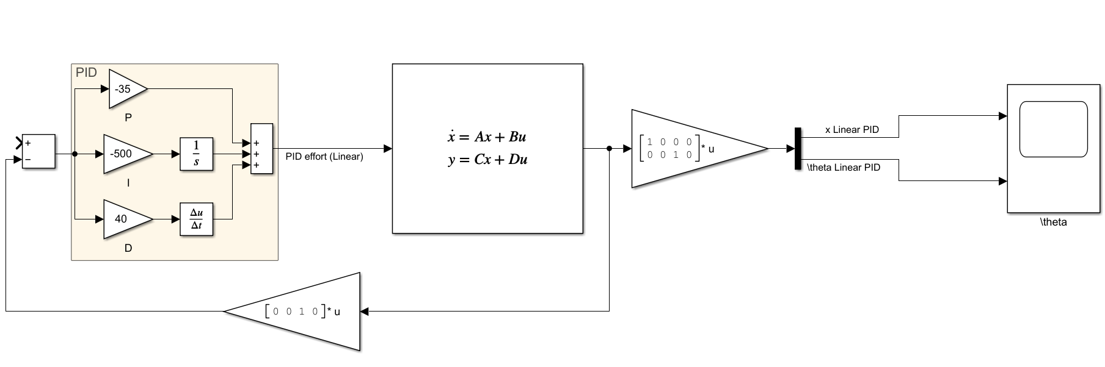

***PID for the shifted system:***

The system poles are,

polese located at , can be ignored as it is far away from the origin and others.

and

therefore,

The answers satisfy the condition of the default Routh criterion,

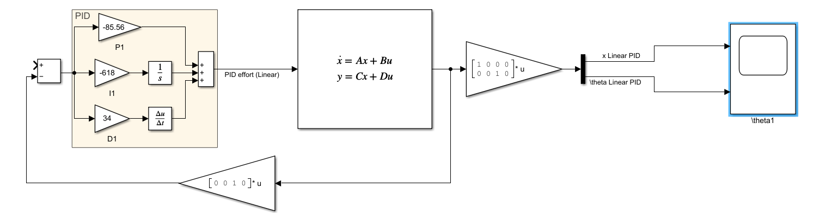

# Problem 3 Description

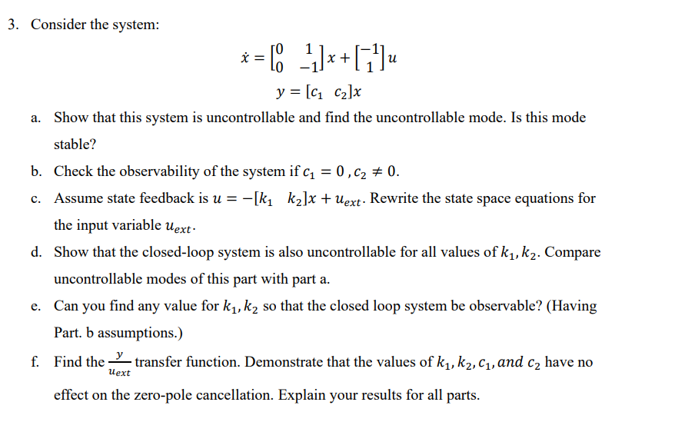

# Solution

1. The controllability matrix is as follows,

PBH method in finding uncontrollable mode,

The eigenvalue of the system is equal to zero, and corresponding eigenvector is,

It is marginally stable.

1. Observability matrix can be written as,
2. Rewriting the state space equation,
3. Forming the controllability matrix,

According to the PBH test, uncontrollable mode is,

Similar to part a.

Observability matrix can be written as,

For , it can be observable.

1. The transfer function of the system can be written as,

It can be observed that always zero-pole cancellation for happens in this system and systems remains uncontrollable.

# Problem 4 Description

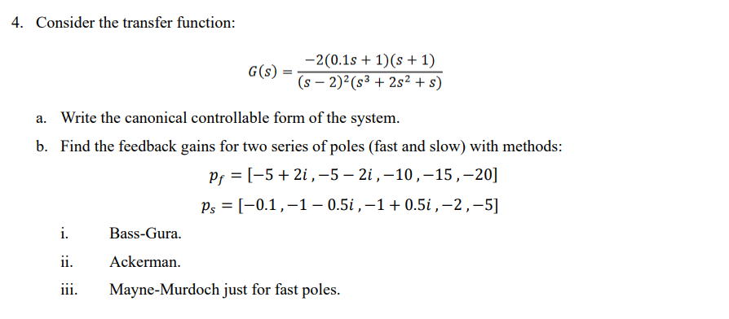

# Solution

The transfer function can be obtained as,

the canonical controllable form can be written as,

therefore, controllability matrix can be written as,

**Bass-Gura,**

**Ackermann,**

**Mayne-Murdoch,**

**:..)**

# Problem 5 Description

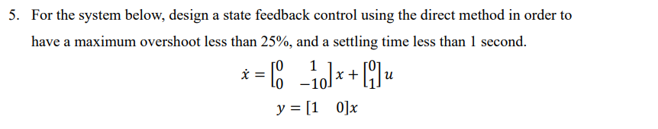

# Solution

Check controllability of the system,

the system is controllable and now we can design a controller.

According to the given information,

Finding

Considering and

For a closed-loop system we have,

which becomes,

In the direct method,

Calculating the determinant of the

Verifying the results with Ackermann!

# Problem 2.1 Description

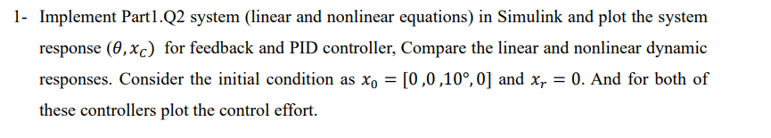

# Solution

The system is implemented in SIMULINK and the results is as follows,

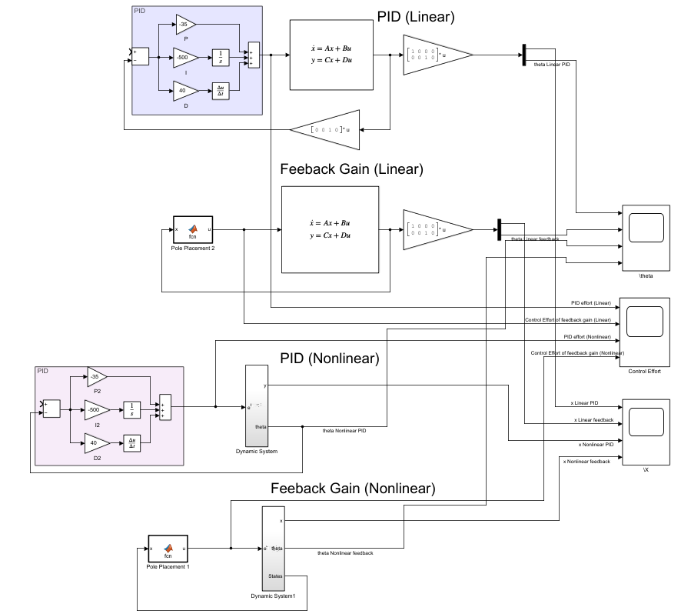

Comparing control efforts is plotted here,

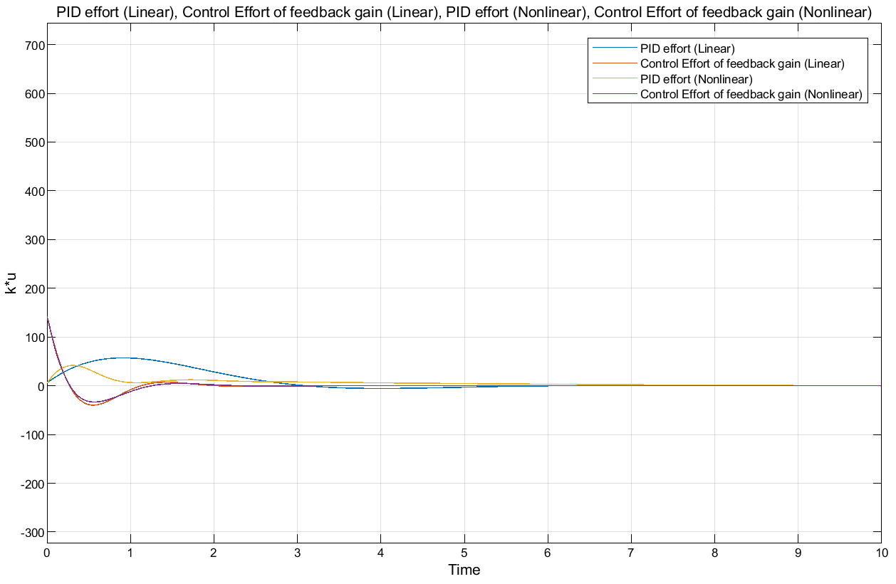

If the square of the signal integral be used, PID controller has much control effort than feedback gain ones,

For comparing we have,

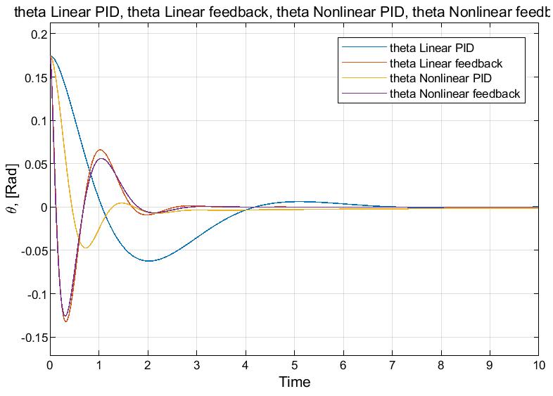

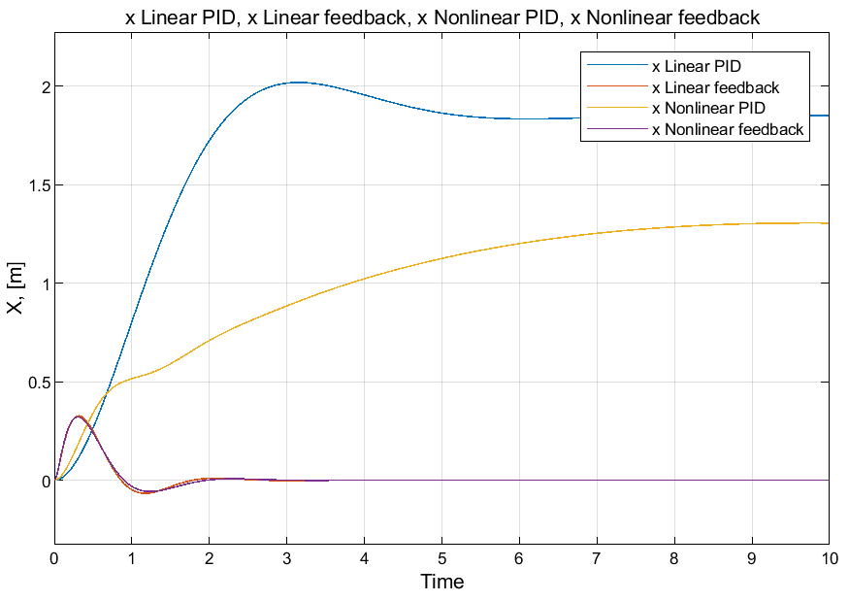

**Figure 1** during a 10 seconds simulation.

It is apparent that the PID controller possesses the capability to stabilize the system. However, due to the lack of feedback from the position signal of the cart, it is unable to regulate the cart's position effectively, resulting in persistent steady-state error. Furthermore, although the overshoot generated by the PID controller is less than that of feedback controllers, its response speed is significantly lower compared to feedback controllers. Furthermore, observations reveal that linear controllers have provided relatively satisfactory responses for nonlinear equations. Considering that the initial angle of the pendulum is set to 10 degrees, linearized equations approximate the same output as the nonlinear equations. Consequently, linear controllers have proven effective for nonlinear equations as well.

# Problem 2.2 Description

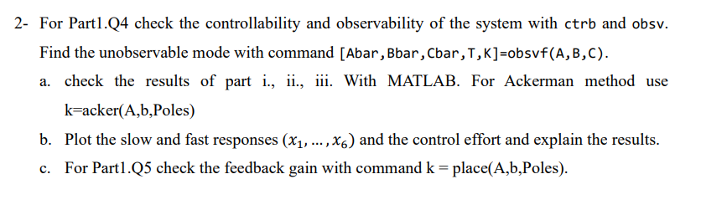

# Solution

Codes have been written in MATLAB and are as follows,

|  |
| --- |
| clc  clear  close all  syms s  p_f=[-5-2i -5+2i -10 -15 -20];  pf=poly(p_f);  pf(1)=[];  p_s=[-0.1 -1-0.5i -1+0.5i -2 -5];  ps=poly(p_s);  ps(1)=[];  A=[0 1 0 0 0;0 0 1 0 0;0 0 0 1 0;0 0 0 0 1;0 -4 -4 3 2];  B=[0;0;0;0;1];  C=[-2 -2.2 -0.2 0 0];  D=[0];  [b,aa]=ss2tf(A,B,C,D)  Co=ctrb(A,B)  fprintf('the rank of controllability matrix is %d. \n',rank(Co))  if rank(Co)==length(Co)  disp('The matrix is full rank and the system is controllable!')  else  disp('The matrix is not full rank and the system is uncontrollable!')  end  Ob=obsv(A,C)  fprintf('The rank of observability matrix is %d. \n',rank(Ob))  if rank(Ob)==length(Ob)  disp('The matrix is full rank and the system is Observable!')  else  disp('The matrix is not full rank and the system is not observable!')  end |

The results can be seen as follows,

|  |
| --- |
| Co =  0 0 0 0 1  0 0 0 1 2  0 0 1 2 7  0 1 2 7 16  1 2 7 16 41  the rank of controllability matrix is 5.  The matrix is full rank and the system is controllable!  Ob =  -2.0000 -2.2000 -0.2000 0 0  0 -2.0000 -2.2000 -0.2000 0  0 0 -2.0000 -2.2000 -0.2000  0 0.8000 0.8000 -2.6000 -2.6000  0 10.4000 11.2000 -7.0000 -7.8000  The rank of observability matrix is 4.  The matrix is not full rank and the system is not observable! |

It can be understood that results are same as the ones obtained in the first part. The system is controllable but not observable. To find out the unobservable mode, obsvf(A,B,C) is used.

|  |
| --- |
| [Abar,Bbar,Cbar,T,K]=obsvf(A,B,C) |

And the response is

|  |
| --- |
| Abar =  -1.0000 -0.8519 -1.5859 2.1583 1.1406  0.0000 1.8869 2.8052 -3.7973 -3.0389  0.0000 1.1449 0.3726 -0.5111 -0.0692  -0.0000 0.0000 0.9335 0.1954 -0.3006  0.0000 -0.0000 -0.0000 0.8384 0.5450  Bbar =  0.4472  -0.8903  -0.0858  0  0  Cbar =  0.0000 -0.0000 -0.0000 0.0000 2.9799  T =  0.4472 -0.4472 0.4472 -0.4472 0.4472  0.2543 -0.2532 0.2429 -0.1399 -0.8903  -0.3075 0.2968 -0.1898 -0.8798 -0.0858  0.4363 -0.3206 -0.8369 -0.0801 0  -0.6712 -0.7383 -0.0671 0 0  K =  1 1 1 1 0 |

The results show the mode corresponding to eigen is unobservable.

1. Results of parts i,ii,iii can be obtained and verified as follows,

|  |
| --- |
| a=[-2 -3 4 4 0];  Psi=[1 a(1) a(2) a(3) a(4)  0 1 a(1) a(2) a(3)  0 0 1 a(1) a(2)  0 0 0 1 a(1)  0 0 0 0 1 ];  %% Fast  k_bass_fast=(pf-a)*inv(Co*Psi)  k_acker_fast=acker(A,B,p_f)  k_acker_fast2=[0 0 0 0 1]*inv(Co)*(pf(5)*eye(5)+pf(4)*A+pf(3)*A^2+pf(2)*A^3+pf(1)*A^4+A^5)  %% Slow  k_bass_slow=(ps-a)*inv(Co*Psi)  k_acker_slow=acker(A,B,p_s)  k_acker_slow2=[0 0 0 0 1]*inv(Co)*(ps(5)*eye(5)+ps(4)*A+ps(3)*A^2+ps(2)*A^3+ps(1)*A^4+A^5) |

Results are same as those calculated in part I.

|  |
| --- |
| k_bass_fast =  87000 48846 10801 1132 57  k_acker_fast =  87000 48846 10801 1132 57  k_acker_fast2 =  1.0e+04 *  8.7000 4.8846 1.0801 0.1132 0.0057  k_bass_slow =  1.2500 11.3750 27.2750 29.1500 11.1000  k_acker_slow =  1.2500 11.3750 27.2750 29.1500 11.1000  k_acker_slow2 =  1.2500 11.3750 27.2750 29.1500 11.1000 |

1. Slow and fast responses as well as control effort are plotted in this part,



**Figure 2** Fast response of the system.



**Figure 3** Slow response of the system.



**Figure 4** Control effort for fast response of the system.



**Figure 5** Control effort for slow response of the system.

The control effort required for achieving a fast response in the system is significantly higher compared to achieving a slower response. Additionally, it is evident that by utilizing fast modes, the system can reach a stable state more quickly than when relying on slower modes.

1. For part 1.Q5 we have:

|  |
| --- |
| %% Problem 5  A=[0 1; 0 -10];  B=[0;1];  C=[1 0];  Poles=roots([1 12.8 64]).';  k=place(A,B,Poles) |

which the answer is as follows,

|  |
| --- |
| k =  64.0000 2.8000 |

which is exactly what we have obtained in part I.